Sellaginella
Kingdom: Plantae
Division: Lycopodiophyta
Class: Selaginellopsida
Order: Selaginellales
Family: Selaginellaceae
Genus: Selaginella

Habit and Habitat of Selaginella:
Selaginella is the only living genus of the order Selaginellales and is commonly known as ‘spike moss’ or ‘small club moss’. It is a large genus comprising of about 700 species distributed all over the world. Abundantly it is found growing in tropical rain forests.
Mostly the species prefer moist and shady places to grow but a few species are also found growing in xerophytic conditions i.e., on dry sandy soil or rocks e.g., S. lepidophylla, S. rupestris etc. A very few species are epiphytes e.g., S. oregena. It is found growing on tree trunks.
A few xerophytic species of Selaginella e.g., S. lepidophylla and S. pilifera show cestipose habit and are sold as curiosities under the name of resurrection plants. They curl and become ball like when dry and again become green and fresh when moisture is available. About 70 species have been reported from India.
They are mainly found growing in eastern as well as Western Himalayas and the hills of South India. Some of the common Indian species are S. repanda, S. biformis, S. denticulata, S. monospora, S. semicordata, S. adunca etc. S. kraussiana is cultivated in green house.

External Morphology of Selaginella:
The sporophyte is an evergreen, delicate herb. Its size varies greatly from species to species i.e., from a few cm. to 20 meters. Plants may be erect or prostrate depending upon the sub-genus. In the sub-genus homoeophyllum the plants are erect e.g., S. rupestris, S. spinulosa etc. and in the sub-genus heterophyllum the plants are prostrate e.g., S. kraussiana, S. lepidophylla etc.
The plant body is distinctly differentiated into following structures (Fig. 1 A, C):
(i) Stem.
(ii) Leaves.
(iii) Ligules.
(iv) Rhizophore.
(v) Roots.
(i) Stem:

It is usually profusely branched, delicate and evergreen. The branching is of monopodial type. The growing apex of the stem consists of either meristematic tissue or a single apical cell. In the sub-genus homoeophyllum the stem is erect and somewhat cylindrical and in the sub-genus heterophyllum it is prostrate with stout erect branches and is somewhat dorsiventral.

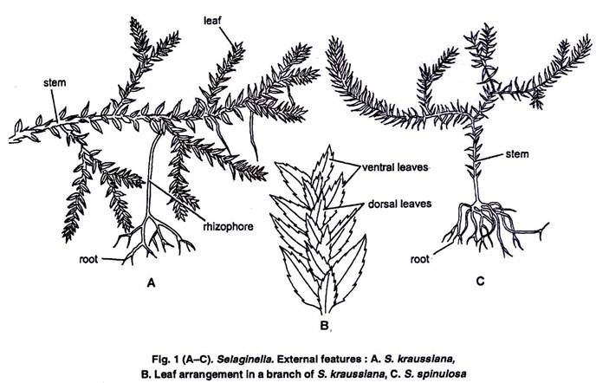

(ii) Leaves:
They are usually small, simple and lanceolate with a pointed apex. Each leaf is provided with a single unbranched midrib. In the sub-genus homoeophyllum all the leaves are of same size and are spirally arranged forming a dense covering.
In the sub-genus heterophyllum the leaves are dimorphic i.e., of two size (small and big) and are arranged in pairs. Small leaves are present on the dorsal side of the stem and bigger ones on the ventral side of the stem (Fig. 1 B). The bigger leaves alternate with bigger ones and smaller leaves alternate with smaller ones.
Usually the leaves near the apical portion of the branch, bear sporangia (micro-or mega) and are called as sporophylls (micro-or mega) respectively. The sporophylls are usually aggregated into a condense structure which is known as strobilus.
(iii) Ligules:
On the adaxial side of the leaf, near the base is present a small membranous out-growth known as ligule. It is embedded at the base of a leaf in a pit like structure known as ligule pit.
It may be tongue shaped (e.g., S. vogelii), fan shaped (e.g., S. martensii), fringed (e.g., S. cuspidata), or lobed (e.g., S. caulescens). It is more than one cell in thickness except at the apex. The structure of the ligule can be differentiated into two parts, glossopodium and the body of the ligule (Fig. 2 A, B).

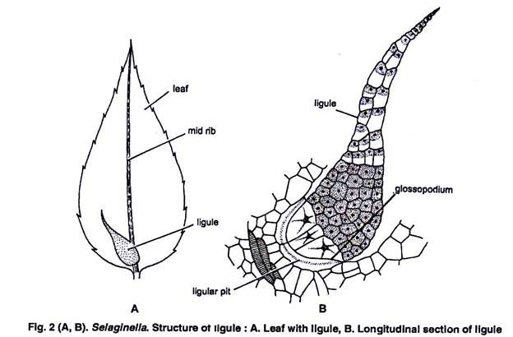
Glossopodium:
It is the basal hemispherical part made up of large thin walled cells. It is surrounded by a glossopodial sheath.
Body of the ligule:
Above the glossopodium is the body of ligule. It is made up of many large and small cells. The function of the ligule is not well known. It may be a water secreting or water absorbing or protective organ. According to Earner (1936) the ligule is perhaps a vestigial organ.
(iv) Rhizophore:
This structure arises from the prostrate axis at the point of dichotomy and elongates downward. It is a colourless, leafless, unbranched and cylindrical structure.
As soon as the free end of rhizophore touches the soil it develops a tuft of adventitious roots at its free end. In few species the rhizophore is present e.g., S. krciussiana while in others it is absent e.g., S. cuspidata. It differs from root in having no root cap and from stem in having no leaves.
The following views regarding the morphological nature of the rhizophore have been proposed:
1. Capless root hypothesis:
According to Harvey Gibson (1902), Uphof (1920), Wochok and Sussex (1974), the rhizophore is a capless root because:
(i) It is positively geotropic.
(ii) It is a leafless structure.
(iii) It is almost similar in anatomy of the root.
(iv) It has a monostelic stele.
2. Leafless shoot hypothesis:
According to Worsdell (1910), Williams (1937), Cusic (1954) etc. The rhizophore is a leaf-less shoot because:
(i) Root cap is absent.
(ii) Root hairs are absent.
(iii) It is exogenous in origin.
(iv) It can develop into leafy shoot under experimental conditions.
3. Sui-generis hypothesis:
According to Goebel (1905), Bower (1908), the rhizophore is an organ “Suigeneris” i.e., having absolutely no parallel structure anywhere in the plant kingdom. Thus, it is altogether a new structure.
Schoult (1938) regarded rhizophore as specialized stem modified in the direction of root because of the root bearing nature.
(v) Roots:
They originate either from the tips of rhizophores or directly from the stem or from the swollen base of hypocotyl (Fig. 1 A, B). Their origin is endogenous. They are usually dichotomously branched structures. The roots are provided with root caps and root hairs.

